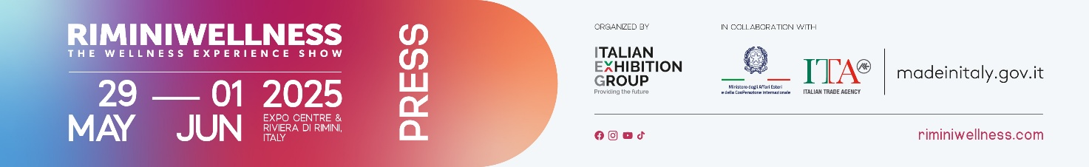

press release
(English translation)

RIMINIWELLNESS 2025 - DAILY NEWS 29 MAY

IL SOLE 24 ORE, RIMINI, THE ITALIAN CAPITAL OF WELLNESS
In the early afternoon, the results of a survey conducted by Il Sole 24 Ore in collaboration with RiminiWellness were announced. The survey includes a special ranking to map well-being in Italian provinces, based on ten indicators such as health, sports, business, and social participation. The survey, presented by Andrea Gianotti, head of the Sole 24 Ore research centre, reveals that Rimini is the most wellness-oriented province in Italy, excelling in the number of sports companies, gyms, and swimming pools, as well as its academic focus on motor sciences. The analysis is based on official data integrated with original metrics, providing a snapshot of the widespread well-being across the region. Following are Isernia and Trieste, while the Adriatic coastal provinces dominate the top ten. The Emilia-Romagna region stands out as one of the most virtuous in Italy, boasting the highest concentration of economic initiatives related to sports, alongside Lombardy and Trentino-Alto Adige. The study can be downloaded at RiminiWellness 2025.

FOREIGN INVESTMENTS AND NEW EXPANSIONS: IS 2025 THE YEAR OF REVOLUTION?
On the first day of RiminiWellness 2025, the Conference of the General States of Fitness and Wellness was held. Notable attendees included Javier Urbano Lopez, General Manager of GoFit Italy, Samuele Frosio, CEO of RSG Group Italy, and Riccardo Turri, CEO of Starpool. The event was hosted by Luigi Angelini, journalist and creator of the General States. The meeting provided a significant opportunity to explore the evolution of fitness offerings in Italy and outline concrete strategies for its growth. In his speech, Riccardo Turri, CEO of Starpool, highlighted how a clear gap has emerged over the years between the demand from athletes and the supply of gyms. A stagnation that has slowed the recognition of wellness as a fundamental component of sports practice. Today, however, a new phase is beginning, marked by significant opportunities where wellness can finally take centre stage, becoming an integral part of training and recovery. This shift is driven by a greater awareness of the offerings, which are increasingly oriented towards advanced models based on scientific evidence and capable of providing a comprehensive and qualified service. In this scenario, gyms are expected to transform into multidimensional spaces where personal care translates into tailored, effective, and sustainable programmes. This vision was echoed by Samuele Frosio of RSG Group Italia, who emphasised the importance of promoting a structural transformation of the market to make Italy a more athletic country. The goal is ambitious but necessary: to surpass the current 9% gym membership rate and approach the 16% rate in Germany. From this perspective, GoFit's entry into the Italian market holds strategic value. As highlighted by the general manager of GoFit Italia, Javier Urbano Lopez, our country offers an extraordinary opportunity for growth and development, aligning with a vision of accessible, inclusive, and future-oriented well-being.

SPORT FACING THE CHALLENGE OF SUSTAINABILITY: A NEW SPACE FOR DISCUSSION AT RIMINIWELLNESS
Contemporary sport is increasingly called upon to address the major global challenges of the circular economy. The theme at the heart of the "Sport and Sustainability Forum, a challenge to win the future," held on the first day of RiminiWellness 2025, was promoted by Ecopneus, a consortium for the recycling of end-of-life tires (ELTs), in collaboration with Ecomondo. Moderated by Luigi Monfredi, Deputy Director of Rainews24, the meeting gathered high-profile contributions from institutions, both nationally and internationally, underscoring the crucial role of sports in achieving the goals of the 2030 Agenda. Following the opening remarks by Giuseppina Carnimeo, General Manager of Ecopneus, who emphasised the importance of regulations and incentives for the development of the circular economy, Senator Claudio Barbaro, Undersecretary at the Ministry of the Environment, delivered a video message highlighting the urgent need for integrated policies between sports and sustainability. Niclas Svenningsen (UN), a climate policy expert, stressed the potential of sports in the ecological transition. Simona Azzolini (Cambridge Institute for Sustainability Leadership) shared this view, highlighting the risks and opportunities for the sector. From UEFA, Michele Uva outlined the sustainability strategy for European football, while Gloria Zavatta (Milan Cortina 2026 Foundation) shared the experience of the Italian Winter Olympics, focusing on innovation and organisational complexity. From the national context, Giampiero Pastore (CONI) discussed the federations' commitment to ESG practices, while Debora Miccio (Istituto per il Credito Sportivo) presented financing tools for sustainable facilities. Lorenzo Marzoli from Sport e Salute underlined the social value of sports and a more equitable governance model. For the industry, Alessio Cremonese, President of Assosport, highlighted the challenges for manufacturing in balancing technical innovation and sustainability. Leonardo Ghiraldini (NATIVA), former captain of the National rugby team, discussed the role of sport in creating regenerative value. A concrete example was provided by Giorgio Pisano (Ecopneus), who demonstrated how rubber recycled from PFU can be transformed into high-performance, low-impact sports surfaces. The forum concluded with a round table discussion between representatives of sports promotion organisations – ASI, UISP, OPES, ASC, CSI – and the Healthy Cities Network, coordinated by Francesco Caroli.

ABOUT RIMINIWELLNESS 2025
Date: 29 May – 1 June 2025; event type: international expo; organiser: Italian Exhibition Group S.p.A.; recurrence: annual; edition: 19th; open to: general public and operators; info: www.riminiwellness.com

PRESS CONTACT ITALIAN EXHIBITION GROUP
head of corporate communication & media relation: Elisabetta Vitali
press office manager: Marco Forcellini, Pier Francesco Bellini | press office coordinator: Luca Paganin | international press office coordinator: Silvia Giorgi | press office specialist: Mirko Malgieri; Nicoletta Evangelisti | media@iegexpo.it
MEDIA AGENCY RIMINIWELLNESS
Naper Multimedia| Zoe Perna | T. +39 02 97699600 | zoe.perna@napermultimedia.it | staff@napermultimedia.it

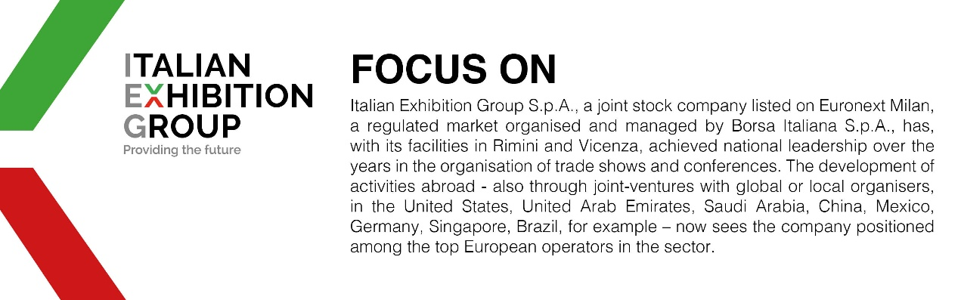

This press release contains forecast elements and estimates that reflect the management’s current opinions (“forward-looking statements”), particularly regarding future management performance, realization of investments, cash flow trends and the evolution of the financial structure. For their very nature, forward-looking statements have a component of risk and uncertainty, as they depend on the occurrence of future events. The effective results may differ (even significantly) from those announced, due to numerous factors, including, only by way of example: food service market and tourist flow trends in Italy, gold and jewellery market trends, green economy market trends; the evolution of raw material prices; general macroeconomic conditions; geopolitical factors and evolutions in the legislative framework. Moreover, the information contained in this release does not claim to be complete, and has not been verified by independent third parties. Forecasts, estimates and objectives contained herein are based on the information available to the Company as at the date of this release.

