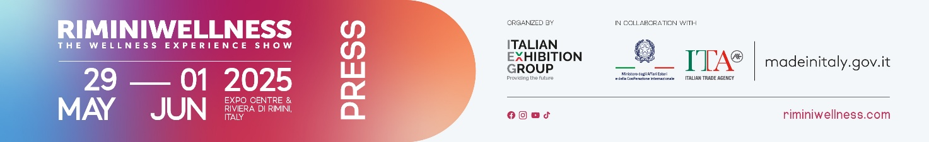

press release
(English translation)

RIMINIWELLNESS 2025 (ITALY) - DAILY NEWS 30 MAY

- In the early afternoon of tomorrow, Saturday, May 31, the event will be attended by the Undersecretary for the Environment and Energy Security, Senator Claudio Barbaro, who will be visiting the show.

WHAT ARE GYM-GOERS LOOKING FOR TODAY? LES MILLS IN COLLABORATION WITH IFO HAVE THE ANSWER
A useful survey to outline the needs of the end user and provide a practical guide for identifying customer needs, enhancing the gym's offerings to stand out in an increasingly competitive market. This is the research conducted by Les Mills in collaboration with IFO – International Fitness Observatory, presented yesterday during the first day of RiminiWellness 2025, in a meeting featuring Giorgio Trappolini, Country Manager of Planet Fitness Italy, and Paolo Menconi, Director of IFO. The survey was conducted on a group of athletes who have been training in clubs or gyms for over five years, with an average frequency of three times a week. Key satisfaction drivers include the quality of the equipment and spaces, followed by cleanliness, staff friendliness, professionalism, and a good value for money. Attendance, on the other hand, is driven by the desire to feel fit, followed by the need to relax and lose weight. Personal care, therefore, takes precedence over socialisation. When it comes to preferred activities, toning leads the way, followed by cardio and strength training, with the latter seeing significant growth among the younger generations.

FITNESS FRANCHISING DAY: PERSPECTIVES AND TRENDS IN THE FITNESS BUSINESS
The first edition of Fitness Franchising Day took place at the start of the second day of RiminiWellness, an international event curated by Italian Exhibition Group held at Rimini Expo Centre and along the Riviera until Sunday, June 1. This initiative brings together franchising, finance, real estate, and growth models in the fitness industry. Promoted in collaboration with Affilya, a consulting network that addresses franchising in a cross-cutting manner, the talk provided an opportunity to share high-value insights and deep dive into key issues for the sustainable and scalable growth of companies in the industry. The debate, hosted by Andrea Maria Meschia, CEO of 3io and founding partner of Affilya, featured Maurizio Bottoni, national head of the fitness and wellness sector at ASI, and Luigi Angelini, a consultant specialising in the development of wellness communities. In the afternoon, Fitness Franchising Day continues with a dedicated session for one-on-one meetings between accredited franchisees and some of the most prominent brands in the Italian and international scene, aiming to foster new business synergies.

THE FUTURE OF WELLNESS: PREVENTION, MOVEMENT, AND PUBLIC POLICIES
The second day of RiminiWellness 2025, an international event by Italian Exhibition Group dedicated to fitness, wellness, and sports, held at Rimini Expo Centre and along the Riviera until Sunday, June 1, saw significant participation in the event promoted by The European House – Ambrosetti, titled "Gyms for Health: Fitness as Prevention and Path to Healthy Lifestyles." This event provided an opportunity to discuss the economic, social, and health impacts of sports practice. Moderated by Emiliano Briante, an Ambrosetti partner and head of the Valore Sport Observatory, the meeting addressed some of the most current issues related to promoting movement, prevention, and healthy lifestyles. It also presented the strategic vision "2050 – Italy in Motion." In the panel dedicated to the connection between lifestyle and health, Matteo Conti, Strategic Marketing Director at Amadori, highlighted the educational role that companies can play in promoting healthy habits, especially among young people. Regarding public policies, Daniele Iacò, president of the Italian Committee for Motor Sciences, emphasised the importance of recognising physical activity as a genuine natural remedy, capable of providing long-term preventive benefits. Pino Di Eugenio, CEO of Matrix Fitness, highlighted the fitness industry's perspective, underscoring the value of gyms as local spaces for physical exercise and health awareness. In closing, Saverio Francesco Mennini, head of the department for programming, medical devices, pharmaceuticals, and policies supporting the NHS at the Ministry of Health, shared some institutional insights on promoting healthy lifestyles within the framework of current prevention policies. Alongside them, other experts from the academic, scientific, and institutional worlds contributed to building a comprehensive framework, highlighting the potential of sport as a cross-cutting tool for well-being and inclusion.

HYROX LAUNCHES ITS THIRD ITALIAN EDITION AT RIMINIWELLNESS
The second day of RiminiWellness marked the start of the third Italian edition of HYROX, the prestigious international event dedicated to competitive fitness. The opening of the competition was a major moment for the national sports scene, marking the debut of a 3-day format, centred around performance, passion, and pushing limits. The fitness race, which combines running, functional exercises, and strength tests, stands out for its engaging and inclusive approach, with categories including Open, Doubles, Pro, and Relay designed to welcome athletes of all levels. The opening day confirmed the strong interest in an event that has become a benchmark in the industry and one of the most trending disciplines on the global scene.

ABOUT RIMINIWELLNESS 2025
Date: 29 May – 1 June 2025; event type: international expo; organiser: Italian Exhibition Group S.p.A.; recurrence: annual; edition: 19th; open to: general public and operators; info: www.riminiwellness.com

PRESS CONTACT ITALIAN EXHIBITION GROUP
head of corporate communication & media relation: Elisabetta Vitali
press office manager: Marco Forcellini, Pier Francesco Bellini | press office coordinator: Luca Paganin | international press office coordinator: Silvia Giorgi | press office specialist: Mirko Malgieri; Nicoletta Evangelisti | media@iegexpo.it

MEDIA AGENCY RIMINIWELLNESS
Naper Multimedia| Zoe Perna | T. +39 02 97699600 | zoe.perna@napermultimedia.it | staff@napermultimedia.it

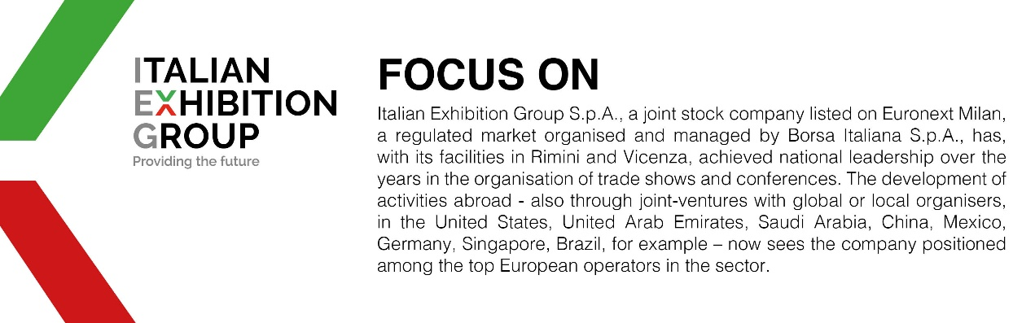

This press release contains forecast elements and estimates that reflect the management’s current opinions (“forward-looking statements”), particularly regarding future management performance, realization of investments, cash flow trends and the evolution of the financial structure. For their very nature, forward-looking statements have a component of risk and uncertainty, as they depend on the occurrence of future events. The effective results may differ (even significantly) from those announced, due to numerous factors, including, only by way of example: food service market and tourist flow trends in Italy, gold and jewellery market trends, green economy market trends; the evolution of raw material prices; general macroeconomic conditions; geopolitical factors and evolutions in the legislative framework. Moreover, the information contained in this release does not claim to be complete, and has not been verified by independent third parties. Forecasts, estimates and objectives contained herein are based on the information available to the Company as at the date of this release.

