

press release no.12

RIMINIWELLNESS 2025 CONTINUES TO BE A STRATEGIC PLATFORM FOR THE FITNESS INDUSTRY

- The event, running at Rimini Expo Centre from May 29 to June 1, serves as a prime B2B platform
- Leading international fitness brands showcase the latest innovations in the industry.
- Assosport attends with 32 companies and over 40 represented brands

Rimini, 29 May – 1 June 2025 - The 19th edition of RiminiWellness 2025, scheduled at Rimini Expo centre from May 29 to June 1 and curated by Italian Exhibition Group, places increasing strategic focus on the business industry. The most innovative companies in the industry are the main players at an event that serves as a hub of excellence for networking among the leading international manufacturers of equipment, technical clothing, and sports accessories. The business area will feature some of the world's leading companies, including Technogym, Panatta, Matrix, Xenios, Gymleco, Lacertosus, and Triform, along with 32 companies associated with Assosport.

AI SOLUTIONS FOR ATHLETIC TRAINING
Technogym, 10-time partner of the Olympic Games, has chosen the RiminiWellness stage to unveil its latest innovations. At the event, the company will be present in various exhibition areas, including a gym entirely dedicated to Pure Strength training, equipped with new rigs and advanced solutions for functional training. Among the main innovations showcased at the show, Technogym Reform stands out as a groundbreaking product that seamlessly blends technological innovation with style, redefining the Pilates experience and making it accessible to users of all levels. Finally, enthusiasts and visitors will have the opportunity to experience Technogym Checkup, an advanced solution that, thanks to artificial intelligence, provides a thorough assessment of physical and cognitive parameters, offering personalised, tailored, and highly precise training programmes.

STRENGTH TRAINING WITH PANATTA AND MR. OLYMPIA CHAMPIONS
A historic brand founded sixty years ago with a well-established presence in the international fitness scene, Panatta will be among the main attractions at the show with a dedicated brand area. Here, visitors can test new equipment in a setting that combines technical excellence with a passion for sports. A fully equipped gym, open to the public and athletes, dedicated entirely to training and innovation. Finally, in the Meet&Greet area, visitors can meet international bodybuilding legends like Ronnie Coleman, Lee Haney, and Phil Heath, champions who have collectively won 23 Mr. Olympia titles. Hany Rambod, the most successful coach ever with 25 Mr. Olympia wins and a key figure in international athletic training, will also be on stage. The meeting will be hosted by Bob Cicherillo, the iconic voice of Mr. Olympia.

MATRIX REDEFINES THE WORKOUT EXPERIENCE WITH NEW CARDIO AND PLATE-LOADED SOLUTIONS
There are also numerous innovations from Matrix, a globally recognised brand of excellence for professional fitness products for both the gym and home, by Johnson Health Tech. The company is showcasing its new Onyx cardio line at RiminiWellness, designed for boutique gyms, hotels, and wellness centres. Additionally, the Magnum range features 10 innovative plate-loaded machines with a robust design, offering even more comprehensive performance. The EGYM ecosystem will also be a key focus for Matrix at the fair, offering a total training experience with isotonic machines and tailored workouts. Other innovations include Stretch Platform and Upper Body Cycle, two comprehensive solutions for pre- and post-workout recovery. In addition to having an exhibition space, Matrix will collaborate with the Italian Fitness Federation (FIF) in the Fitness Body Building and Personal Trainer area.

360-DEGREE TRAINING WITH XENIOS
Xenios USA provides industry professionals with the opportunity to explore the latest innovations in Personal Training, Functional Training, Strength & Conditioning, Hybrid Training, and Cross Training. Finally, there will be innovations in Athletic Preparation and Return to Play. Xenios will occupy two large areas at the event featuring high-intensity workouts, Deadlift Battle and Squat Race competitions with Elisa Vinante, and practical sessions of CrossFit® Italia.

GYMLECO DEBUTS AT RIMINIWELLNESS BRINGING ITS 30 YEARS OF EXPERIENCE
With over 30 years of experience and thousands of installations in gyms across Europe, the Swedish brand Gymleco is exhibiting for the first time at RiminiWellness, bringing its essential vision to the Italian market. The company will showcase a selection of plate-loaded and selectorised machines designed to maximise training effectiveness. Visitors can also attend demo sessions led by qualified trainers, including Ludovico Lemme, a renowned fitness influencer, trainer, and CEO of Rhino Nation.

COMPLETE SOLUTIONS FOR FUNCTIONAL TRAINING AND HOME FITNESS FROM LACERTOSUS
Lacertosus is at RiminiWellness with a wide range of professional equipment for functional training and strength & conditioning, including complete solutions for functional training with high-quality accessories. In addition to its offerings for industry professionals, Lacertosus also provides specialised consulting, products, and tailored solutions for home fitness, perfect for transforming your home into a fully equipped gym space.

TRIFORM: ITALIAN EXCELLENCE IN MODULAR SOLUTIONS FOR FUNCTIONAL TRAINING
Triform, an Italian company specialising in the design and implementation of modular solutions for functional training, showcases its bridge structures dedicated to functional training. These structures are enhanced by an innovative sliding rail for punching bags, designed to optimise space and make training even more versatile and effective. Finally, a product designed for both strength and functional exercises will launch a new product family under the brand.

INDUSTRY ASSOCIATIONS CONFIRM STRONG PRESENCE
The business sector of RiminiWellness is further strengthened by the active participation of leading industry associations, including the fitness companies of Assofitness, a sector chaired by Andrea Pavolucci. More than 30 member companies will exhibit, representing over 40 brands, including: Canali System, Visa Sport, SPART, TRX Transatlantic Fitness Italia, Diamond, TOORX Professional, Genesi, Lite Sport, Real VT, Guglielmi, Desmotec, Acquacom, Blue Drink, WellBack System, Aqquatix, Postura e Sport, Planet Fitness Italia, Gladius Europe, Tecnocomponent, Pilatech, JK Fitness, Gabel, Faress, Blor, World Pilates, Leone, Teca, Fourtune, Kappa, XFit Align Pilates, Djo Compex, Pharmabiogen, and of course the P&G Group.
"We are very pleased with the collaboration between Assofitness and Rimini Wellness," explains President Andrea Pavolucci. "This year, the event has once again attracted great interest and participation from our members. We believe this synergy is extremely positive: it represents a pivotal moment for the entire fitness and wellness industry, a real opportunity for visibility, dialogue, and growth for companies committed to innovation and quality.”

ABOUT RIMINIWELLNESS 2025
Date: 29 May – 1 June 2025; event type: international expo; organiser: Italian Exhibition Group S.p.A.; recurrence: annual; edition: 19th; open to: general public and operators; info: www.riminiwellness.com

PRESS CONTACT ITALIAN EXHIBITION GROUP
head of corporate communication & media relation: Elisabetta Vitali
press office manager: Marco Forcellini, Pier Francesco Bellini | press office coordinator: Luca Paganin | international press office coordinator: Silvia Giorgi | press office specialist: Mirko Malgieri; Nicoletta Evangelisti | media@iegexpo.it

MEDIA AGENCY RIMINIWELLNESS
Naper Multimedia| Zoe Perna | T. +39 02 97699600 | zoe.perna@napermultimedia.it | staff@napermultimedia.it

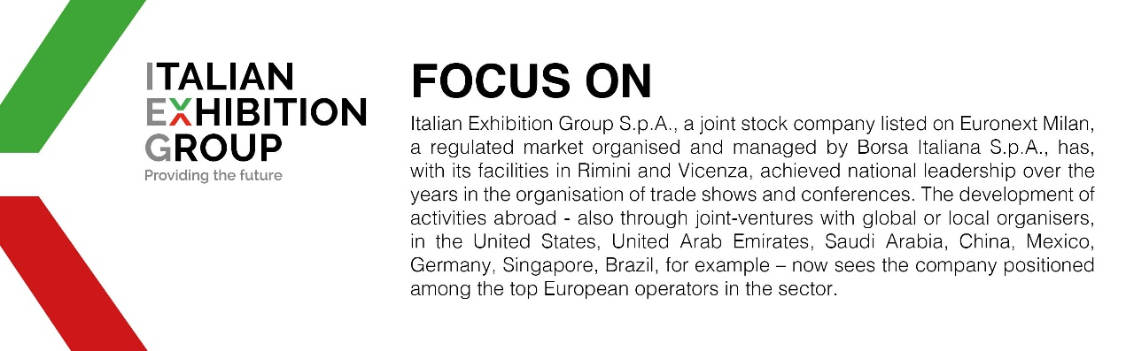

This press release contains forecast elements and estimates that reflect the management’s current opinions (“forward-looking statements”), particularly regarding future management performance, realization of investments, cash flow trends and the evolution of the financial structure. For their very nature, forward-looking statements have a component of risk and uncertainty, as they depend on the occurrence of future events. The effective results may differ (even significantly) from those announced, due to numerous factors, including, only by way of example: food service market and tourist flow trends in Italy, gold and jewellery market trends, green economy market trends; the evolution of raw material prices; general macroeconomic conditions; geopolitical factors and evolutions in the legislative framework. Moreover, the information contained in this release does not claim to be complete, and has not been verified by independent third parties. Forecasts, estimates and objectives contained herein are based on the information available to the Company as at the date of this release.

